**Processes in river basin hydrology and water management  
Exercise 3 – Vegetation Processes & Change**

Please upload the completed assignment to the Brightspace site of the module.

**Problem 1**

Interception evaporation can be a significant flux in many regions worldwide and in particular in forested landscapes. As the interception process is a threshold process, it introduces non-linearity into the hydrological system: throughfall and eventual infiltration into the soil (Pe) is only occurring once a catchment specific threshold, the interception capacity (here: Si,max=2,5mm), is exceeded. In short, here for each day Pe is the amount of water that cannot be stored in the interception store (Si) of vegetation on that day.

Use the data given in the Excel file “Interception” for two catchments, the German Weetbach and the Northern Scottish Allt Coarie Na Con, with very similar long-term mean precipitation P and potential evaporation Ep and calculate for each of the two catchments Pe for each day of the time series. Do this as a simple water accounting scheme following this sequence:

1. Consider for each day the water balance Si(t)=Si(t-1)+P(t)-Pe(t)-Ei(t). Thus, at each day precipitation P enters the storage Si. On some days, the water already in Si plus the precipitation of that day will exceed the storage thresholds Si,max. On these the difference between them, i.e. Si(t)-Si,max, will leave as Pe(t). How high is Pe(t) on days when the thresholds is not exceeded?
2. Each day, after excess water Pe has left, some of the water left in Si will evaporate at potential rates (i.e. Ei=Ep) and therefore reduce the water stored in Si.

**Answer the following questions:**

What are the ratios of long—term mean throughfall Pe over long-term mean precipitation P in the two catchments, respectively?

How different are the ratios? In which catchment is interception evaporation more important and does more water reach the soil? What causes this difference?

**Note:** (a) assume that the interception storage is empty before the first day given in the data (i.e. Si(0)=0); (b) the water stored in Si at the beginning of each day Si(t) equals the water stored at the end of the preceding day Si(t-1); (c) make sure that never more water evaporates than is stored in Si!

Si,max = 2,5 mm

Ep

P

Ei

Pe

**Problem 2:**

Precipitation water that is not intercepted by vegetation, built surfaces or the soil surface will eventually infiltrate as P into the unsaturated root zone of the soil. However, the water volume SR (“Rootzone Storage Capacity”) that does not drain away and that is accessible to plants in the unsaturated zone is difficult to estimate as detailed observations of root depths and soil porosity are typically not available. However, SR can also be estimated at the catchment-scale using water balance data.

Please use the water balance data for the German Weetbach catchment given in the Excel file “Rootzone Storage Capacity” to estimate the plant accessible soil water volume SR,5yr, using the storage-deficit method (see lecture slides). Here, assume that vegetation developed a root zone that allows access to sufficient water to bridge droughts with return periods of 5 years (i.e. SR,5yr is equal to the highest storage deficit over 5 years).

In the Excel file, water balance data for 2 time periods are given (2009-2013 and 2014-2018): in October 2013 the catchment was completely deforested.

**Answer the following questions:**

How high is SR,5yr for the pre-deforestation period and for the post-deforestation, respectively?

Plot both periods into the Budyko space (i.e. x-axis: EP/P, y-axis: ET/P; use 5 year mean values for all variables!). Into which direction did ET/P shift after deforestation?

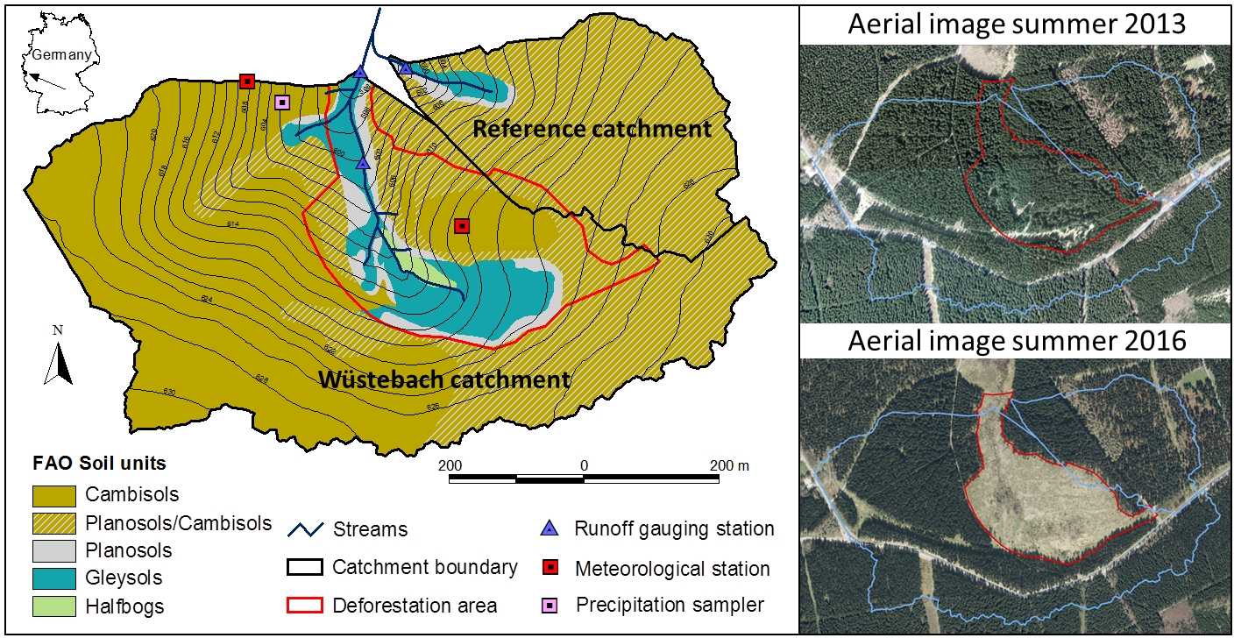

Figure 1: Weetbach catchment (red outline) pre- and post-deforestation